**Chapter 4**

**CONCEPTUAL FRAMEWORK**

Android Based Passengers Monitor is an android based van booking system that provides the passengers (that use the application) of Ma. Evenia Van Services a handy monitor as to their current location and the current route that the van is taking. It also shows all the necessary information that a passenger may want to know like; the van’s plate number and the driver’s personal information. The application is also able to show the passengers designated drop off point and exact amount he/she has to pay for the trip. This way, it is easier for passengers to monitor (1) where they are going and when they will arrive, (2) who is driving, (3) what van they are riding and (4) how much they are paying. And in case some passengers are running a little out of their schedules, the application also allows the users to book a seat so they can scratch off worrying about catching a ride. (Note that cancellation of reservations must be done 2 hours before the trips departure. The driver may also veto the registration and give up the seat if the passenger is not present in the time allotted)

The process starts with registering the driver onto the system so as to provide the application with the driver’s basic information. After which the administrator provides the system with the van’s basic information (plate number, number of seats, etc.) which that driver will use. Once done, the administrator will then save that information and the system will store such information onto its database. For the user’s side, they won’t have to register anymore. What’s shown is the user’s UI, map, driver and van’s information.

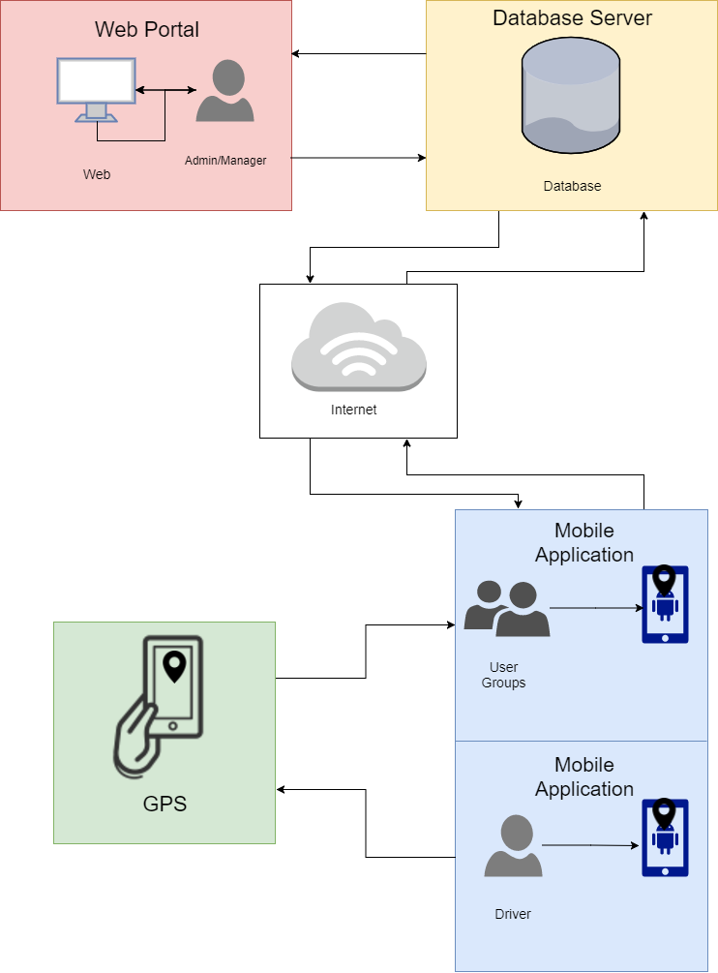

**Figure 4.1: Conceptual Framework**

As shown in figure 1, the admin is responsible for inputting data to the web program (data such as registering the driver, the van’s information, etc). After such data is acquired, the system then stores it in the database of the program. Then the information is obtained via internet from the database server to the mobile application. User’s interface is different from the driver’s interface that’s why in the figure shown it is separated. While the GPS functionality relays microwave signals to the GPS receivers (driver and user groups) to determine the current location.

**Software Applications and Tools used:**

The following are the software apps and tools used by the proponents in developing the system.

**Android Studio 3.0**

The Android Studio is an integrated development environment (IDE) for Android platform development based on Jet Brains’ IntelliJ IDEA software. Using java programming language, the researchers developed the mobile application using this IDE.

**Adobe Photoshop CS6**

Photoshop has vast support for graphic file formats but also uses its own PSD and PSB file formats which support all the aforementioned features. In addition to raster graphics, it has limited abilities to edit or render text, vector graphics (especially through clipping path), 3D graphics and video. Photoshop's feature set can be expanded by Photoshop plug-ins, programs developed and distributed independently of Photoshop that can run inside it and offer new or enhanced features.

**Firebase**

The Firebase is a software application platform which is owned by Google. Using Firebase helps build better mobile applications fast without managing it’s infrastructure. Firebase is widely used platform by top apps in Google Play Store.

**Google Maps API**

The Google Maps APIs provide applications with full access to Google's worldwide database of over 100 million business listings and Points of Interest. Whether you need to show your users nearby bars, coffee shops, airports or grocery stores, you can provide a filtered list of places that are most relevant to the users.

**XAMPP**

Stands for Cross-Platform, Apache, MariaDB, PHP, and Perl (XAMPP). This is a basic Apache distribution that makes it to a great degree of simplicity for developers to establish and create a local web server through local computer for testing and deployment process.

**GitHub Desktop**

Github is a desktop-based git control repository for collaboration. Github offers the greater part of distributed version control and source code administration (SCM) usefulness of Git and in addition including its own particular features.

**Sublime Text 3**

Sublime text is a proprietary cross-platform source code editor with a Python (API). Mainly it supports numerous native and mark-up languages (like HTML) for software and web development.

**System Development Model**

The researchers used the Agile Model - SDLC to develop the system. This will help with the development of the proposed project.

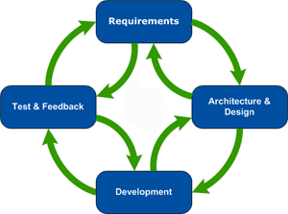

**Figure 4.2:** Android Based Passenger’s Monitor Development Life Cycle

As shown in Figure 2, Android Based Passenger’s Monitor is a simple at the same time dynamic android application, therefore to provide a specific goal for the success of the system; agile model will be used as foundation for the development of the system for it is a combination of iterative and incremental process . The agile model is one of the most commonly used ways in developing systems. Development using agile model has an adaptive approach which is able to resolve and respond to change of requirements of the clients. Moreover, this model focus on rapid delivery of working the software product then at the end of of the iteration, a working software product is then delivered to the customer.

* **Requirements** - In this phase, data that are required in developing the system is gathered and analyzed. The proponents are able to gather information through conducting interview and handing out survey questionnaire to respondents and will be used for software requirements. In its flexibility, the proponents may iterate anytime and respond to drastic changes.
* **Architecture & Design -** In this phase, system’s architecture is defined for instance the behavior of the system and how the system works. System then is designed according to the information gathered from the previous phase. In its flexibility, the proponents may iterate anytime and respond to drastic changes.
* **Test & Feedback -** In this phase, testing is done after a module or functionality is finish. In its flexibility, the proponents may iterate anytime and respond to drastic changes.
* **Development -** In this phase, after a module or component is developed, the system is delivered to the customer. In its flexibility, the proponents may iterate anytime and respond to drastic changes. After the system is fully developed, then implementation takes place. Maintenance is done to see if the system’s properly functioning and if some new features will be added.